Sets and stuff

* They don’t have duplicate values
* Singleton: Set with only one value
* “e Є S” states that e is an element of S
* Natural Number is an unsigned int
* Real number is any signed number from positive to negative infinity
* The empty set is a subset of every set WOO HOOOOOOOOOOOOOOOOOOOOO
* Every set is a subset of itself????????????????/
* Honk honk honk honk honk hon
* S ⃀ F means that S is a proper subset of F
* S C F means that S is a subset of F, but S is not equal to F

Manipulation of sets

* A U B is the union set that contains elements in A and B
* A = {1, 2, 4}
* B = {3, 4}
* (A U B) = {1, 2, 3, 4}
* A ꓵ B is the intersection set that only contains elements found in both A and B
* (A ꓵ B) = {4}
* A – B is the difference contains elements that are in A, but not in B
* (A – B) = {1, 2}
* (B – A) = {3}
* Erm what the spruce
* Erm what the spruce
* A x B is the cartesian product of A and B
* {(a, b} | (a Є A) ^ (b Є B)}
* (A x B) = {(1, 3), (1, 4), (2, 3), (2, 4), (4, 3), (4, 4)}
* POW(S) is the power set, the set of all subsets of S
* POW(S) = {T | T ⃀ S}
* POW(A) = { {}, {1}, {2}, {4}, {1, 2}, {1, 4}, {2, 4}, {1, 2, 4} }
  + 8 elements
* Power sets have a length corresponding to (2^n) when (n = length of set S)

Venn Diagrams

* (A U B) – C = (A – C) U (B – C)

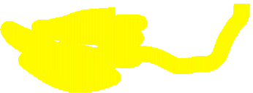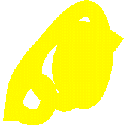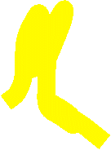

* Only keep the elements highlighted in this scenario